Introduction to Biochemistry

Day 1: Introduction

06/30/18

1. How many water molecules does it take to form a monolayer (one molecule thickness) around the entire surface of an *E. coli* cell? The surface of a sphere is 4πr. Assume that an *E. coli* cell is an ellipse with surface are of π\*length\*width. Diameter of *E. coli:* ~1µm; length of *E.* *coli*: ~3µm

2. Why do fishes survive in frozen lakes?

3. Catechols substituted with long-chain alkyl groups are the components of poison ivy and poison oak that produce the characteristic itchy rash. If you were exposed to poison ivy, which of the treatments below would you apply to the affected area? Justify your choice.

a) Wash the area with hot water.

b) Wash the area with dilute vinegar.

c) Wash the area with water and soap.

d) Wash the area with water, soap and baking soda.

4. Draw the hydrogen bonds between guanine and cytosine, and adenine and thymine.

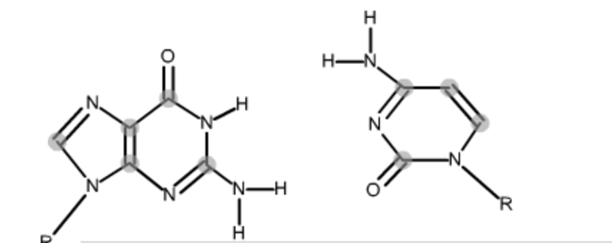 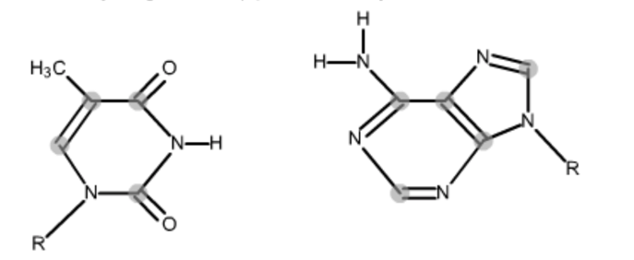

5. Carbon Monoxide (CO) has a much higher affinity for Hemoglobin than O2. What effects would inhalation of CO be predicted to be observed in the body?

6. The amino acid glycine is often used as the main ingredient of a buffer in biochemical experiments. The amino group of glycine, which has a pKa of 9.6, can exist either in the protonated form (—NH3+) or as the free base (—NH2) because of the equilibrium.

R—NH3+ ⇔ R—NH2+ H+

(a) In a 0.1 m solution of glycine at pH 9.0, what fraction of glycine has its amino group in the —NH3+ form?

(b) How much KOH must be added to 1.0L of 0.1M glycine at pH 9.0 to bring its pH to exactly 10.0?

(c) In order to have 99% of the glycine in its —NH3+ form, what must the numerical relation be between the pH of the solution and the pKa of the amino group of glycine?